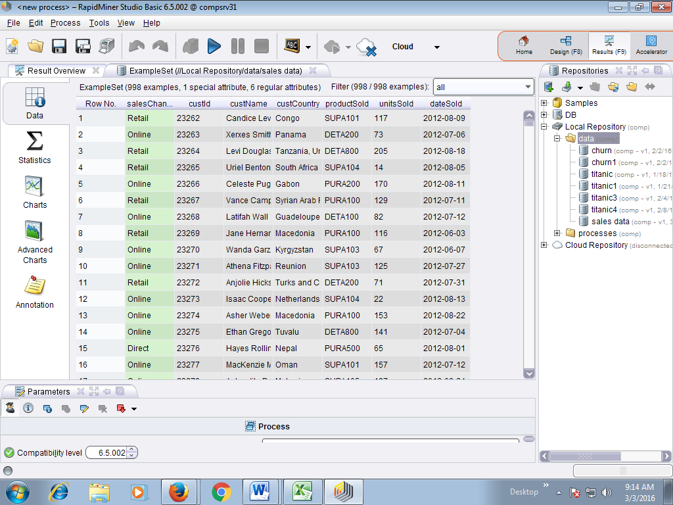

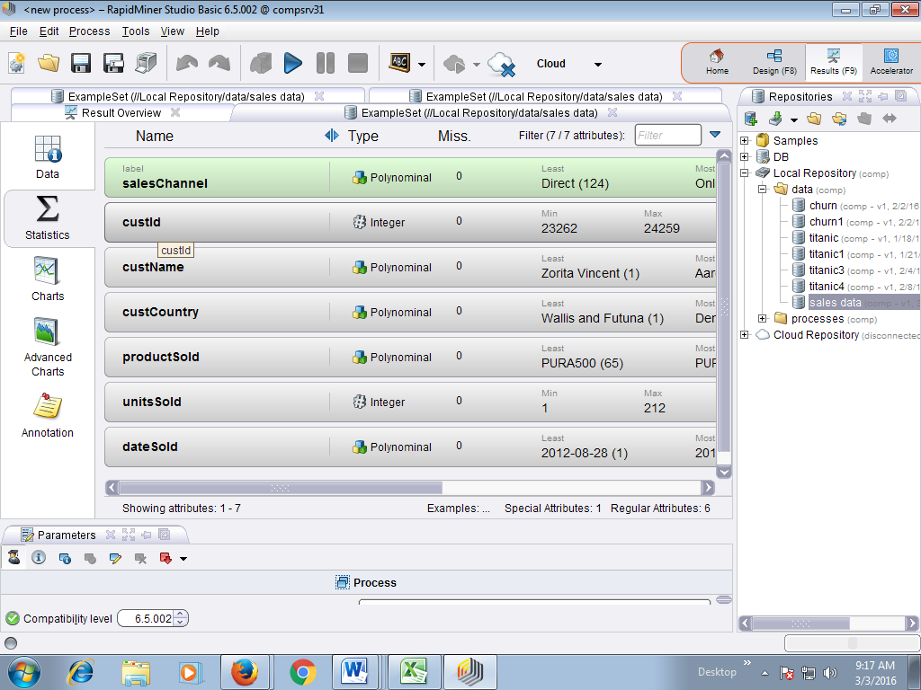

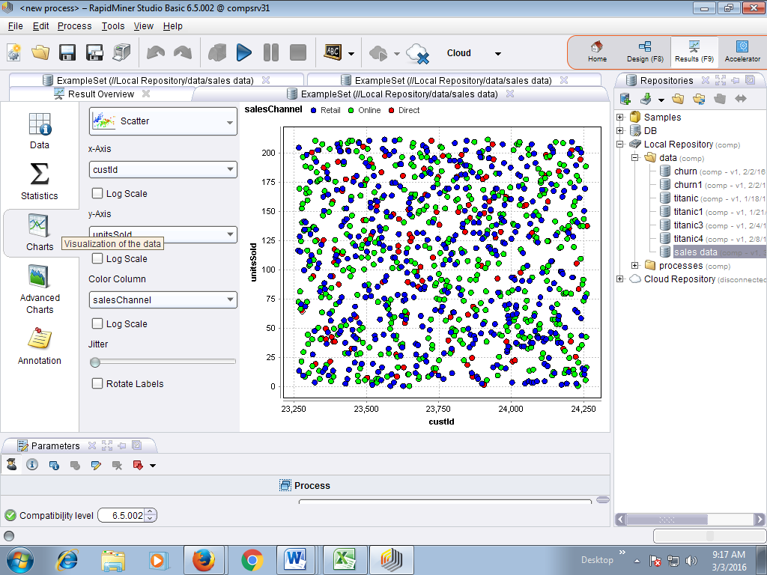

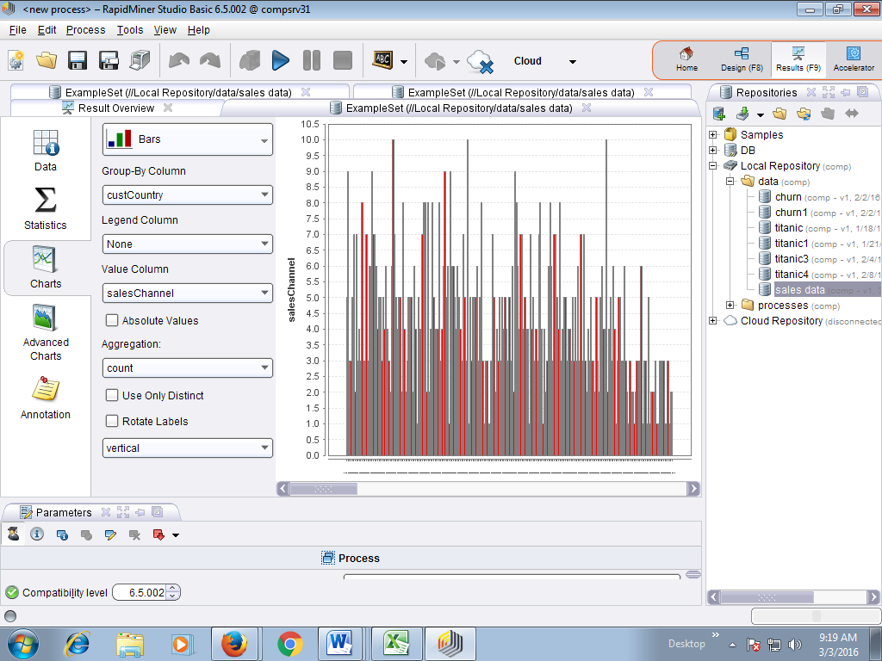

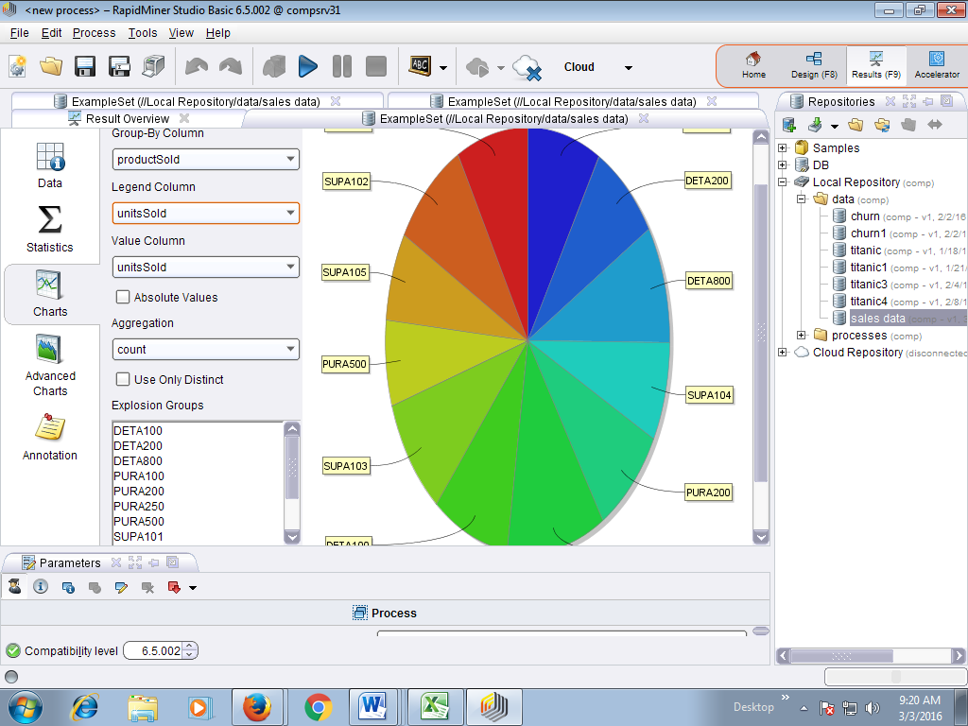

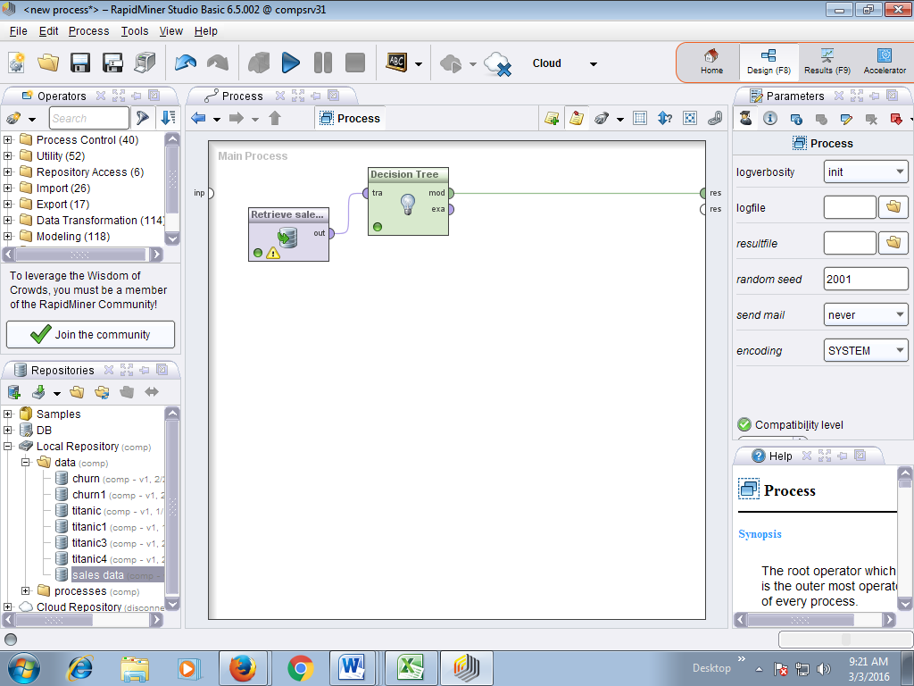

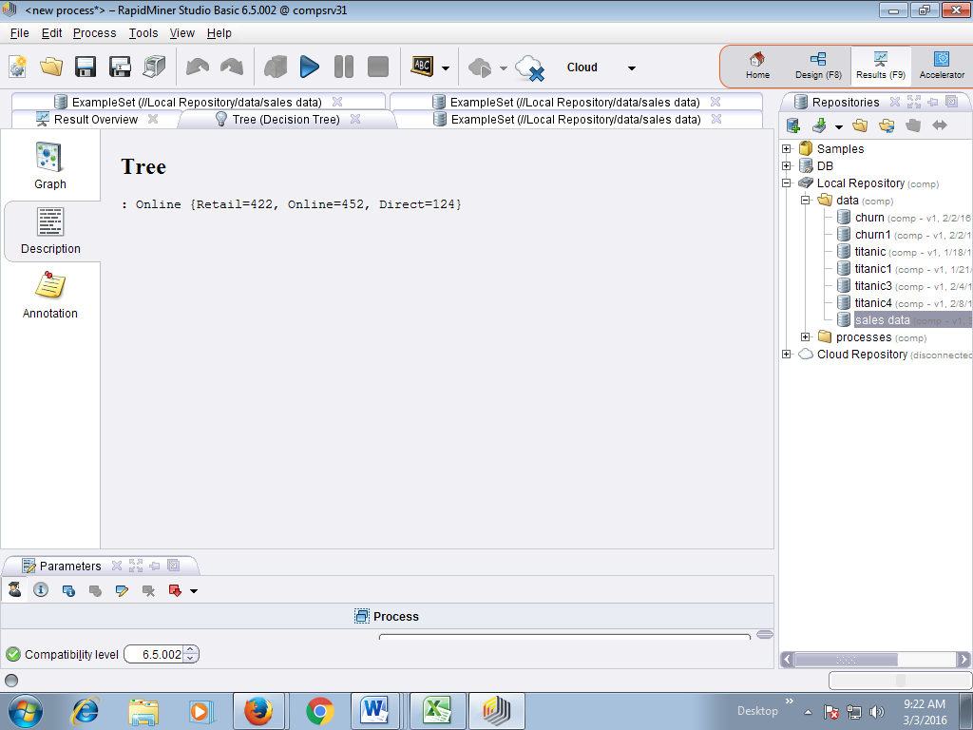

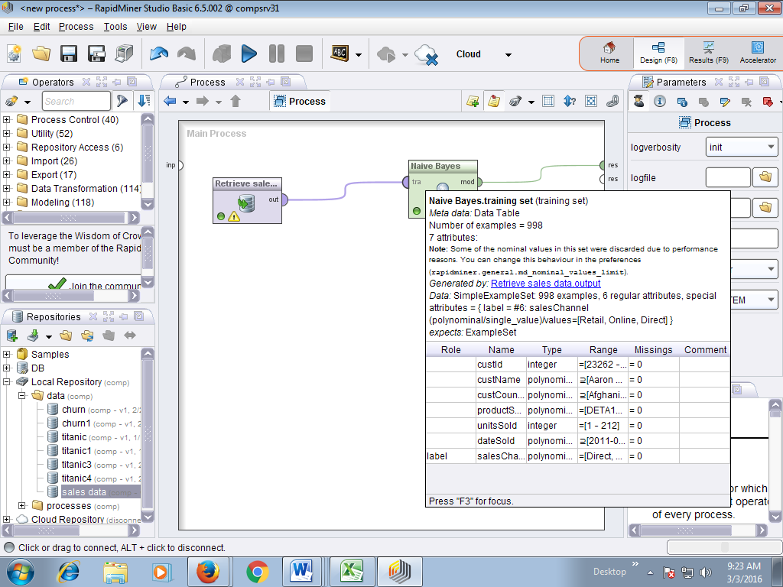

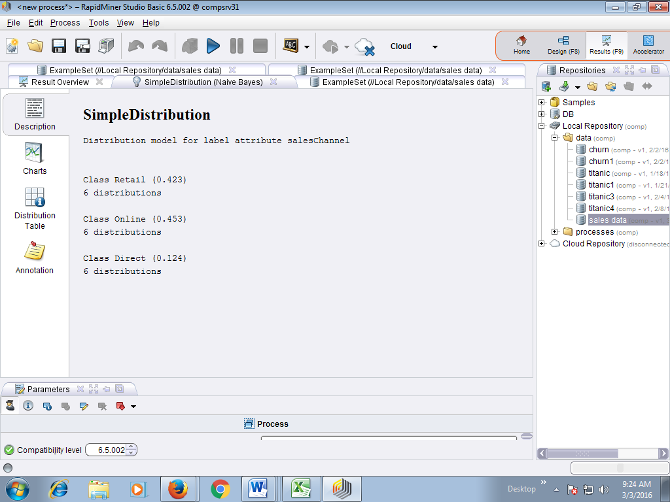

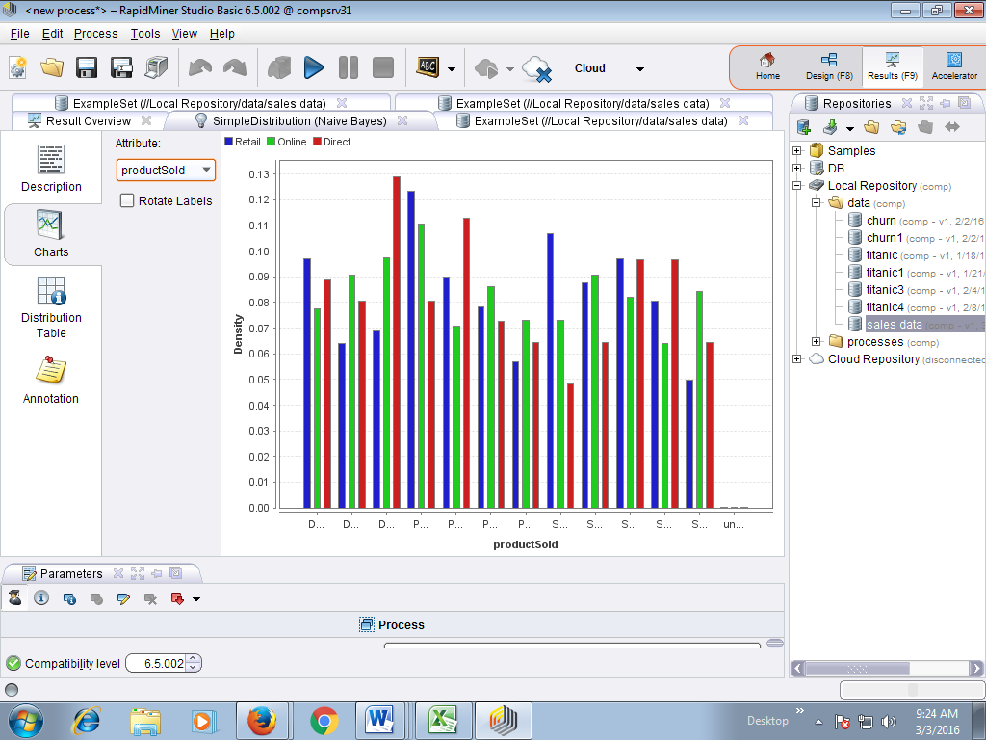

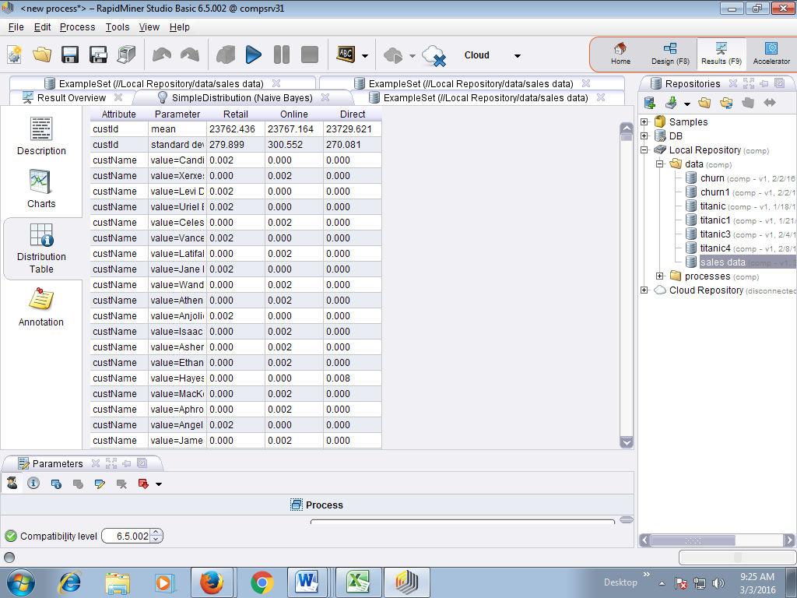

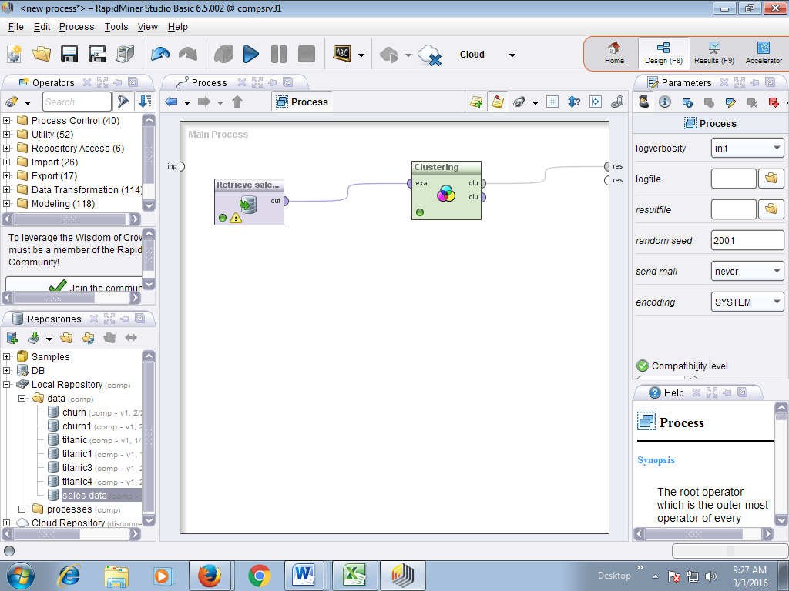

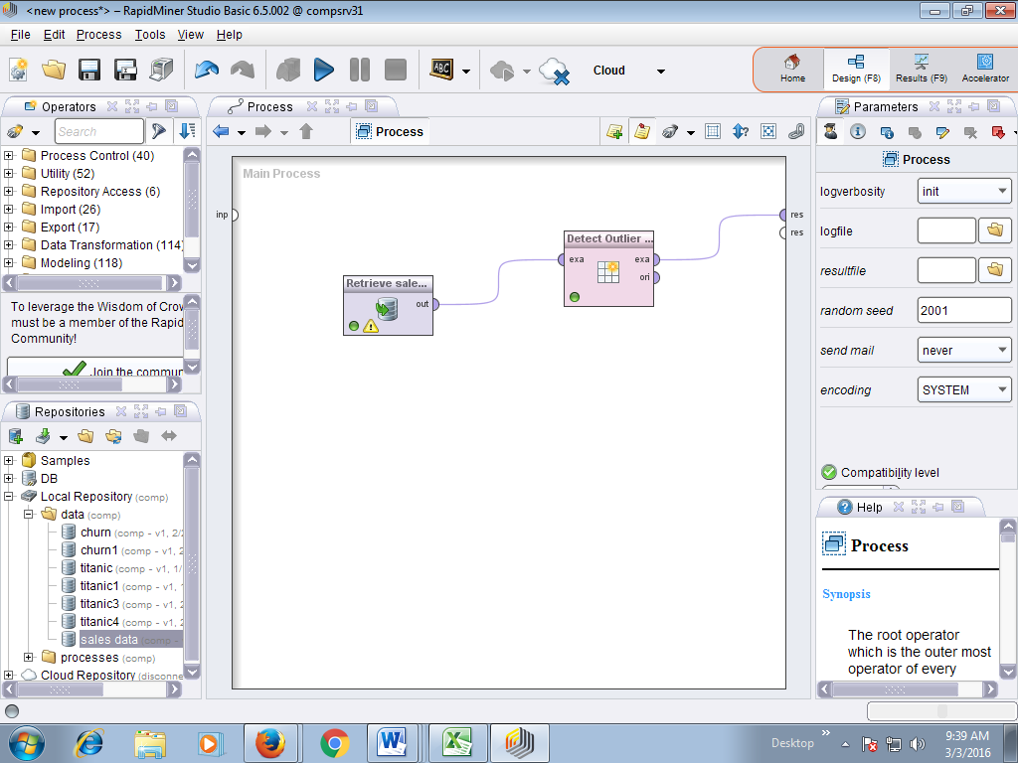

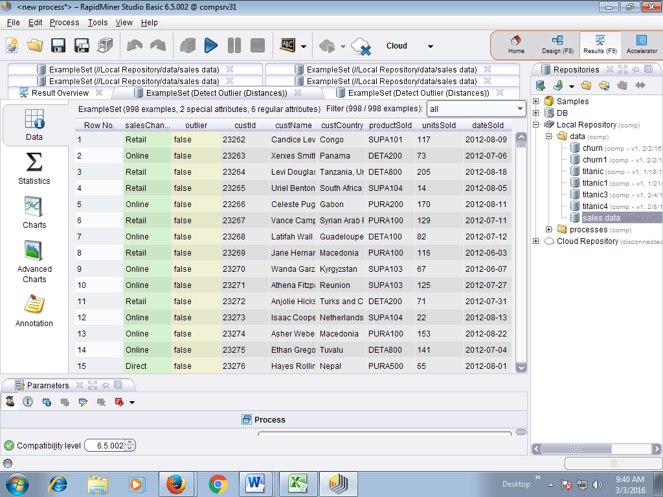

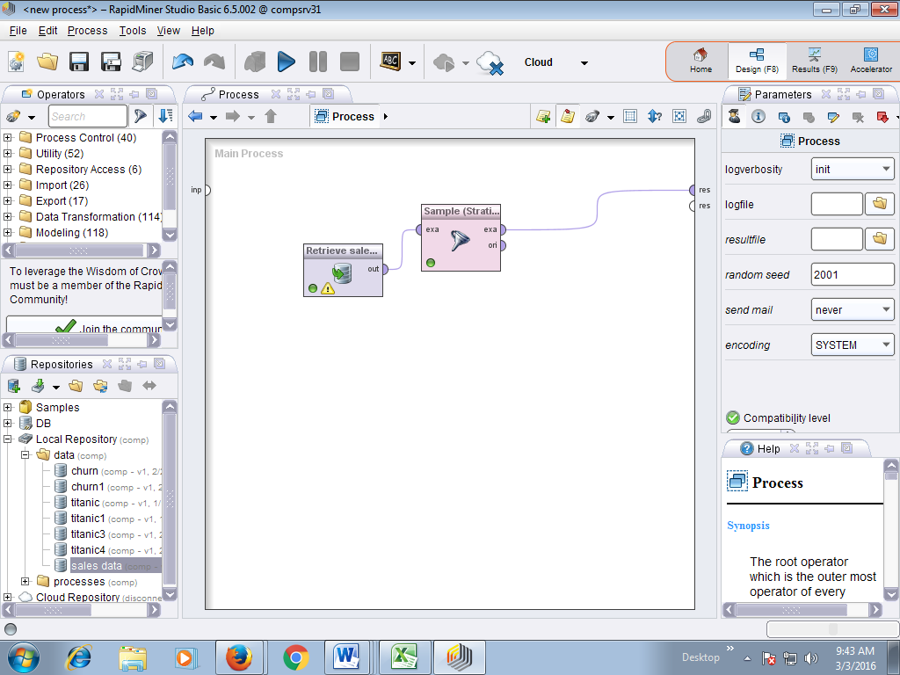

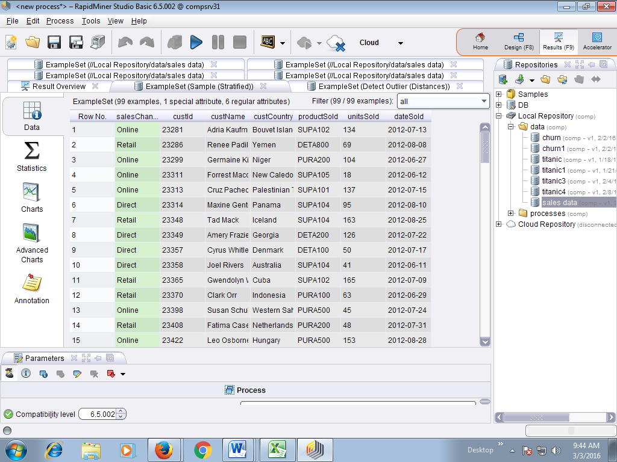

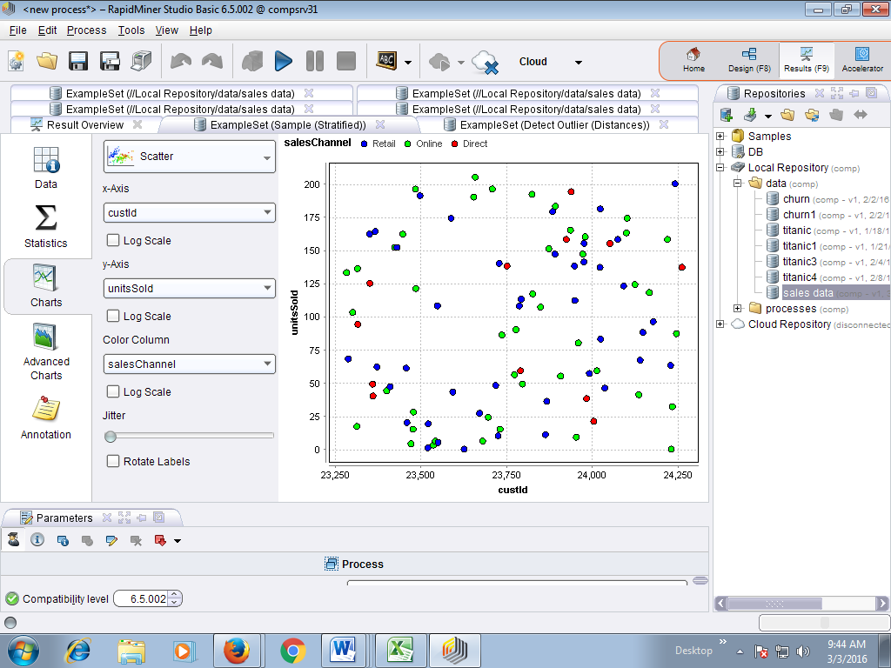

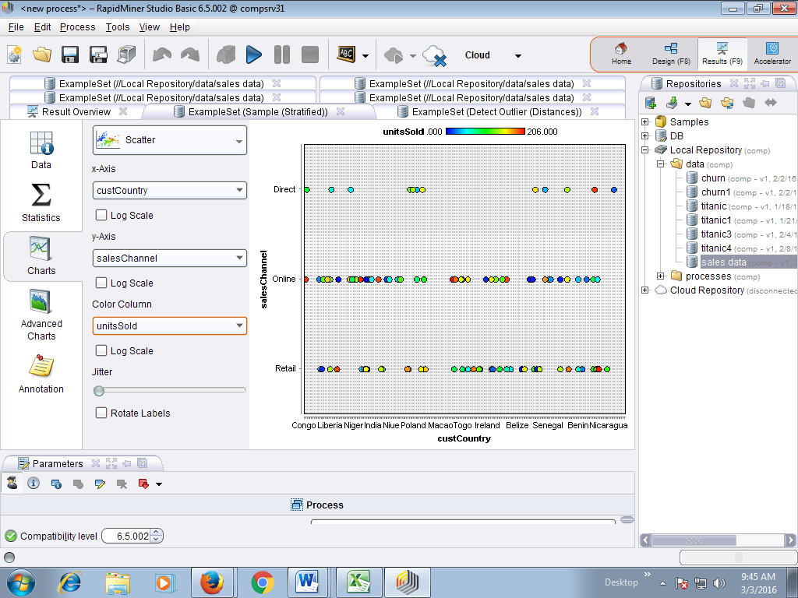

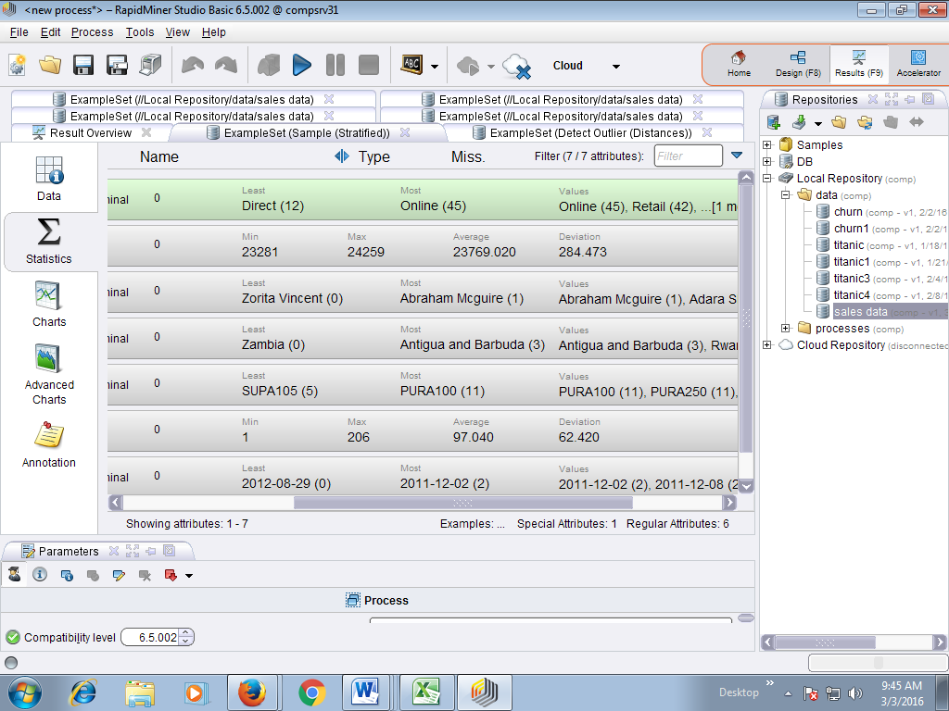

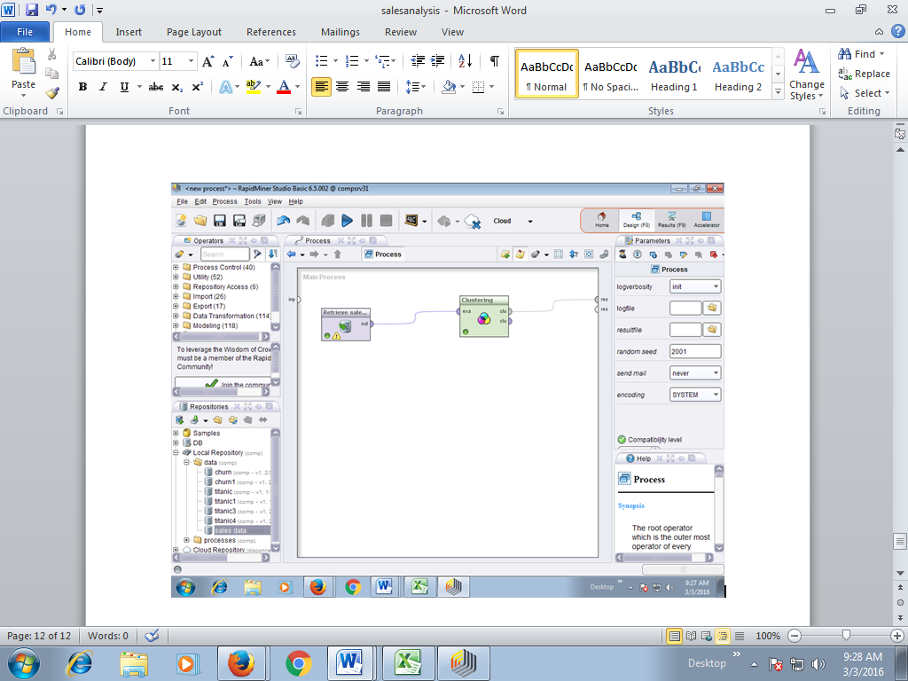

|  |  |  |  |  |
| --- | --- | --- | --- | --- |
| **Decile** | **Mean** | **Std.Dev.** | **Min.** | **Max.** |
| **1** | 0.966667 | 0.182574 | 0 | 1 |
| **2** | 0.433333 | 0.504007 | 0 | 1 |
| **3** | 0 | 0 | 0 | 0 |
| **4** | 0 | 0 | 0 | 0 |
| **5** | 0 | 0 | 0 | 0 |
| **6** | 0.166667 | 0.379049 | 0 | 1 |
| **7** | 0 | 0 | 0 | 0 |
| **8** | 0 | 0 | 0 | 0 |
| **9** | 0 | 0 | 0 | 0 |
| **10** | 0 | 0 | 0 | 0 |